CSULB — College of Engineering
Computer Engineering
Senior Design Project
CECS 490
Author: Rodrigo Becerril Ferreyra
Teammates: Colton Curtis, Kevin Nguyen, Ethan Hua
Professor Dan Cregg
Table of Contents
Executive Summary 3
Responsibilities 4
Overall Progress Report 5
What We Learned 6
What We Would Have Done Differently 6
Feedback for the Professor 7
Expected Final Grade 7

Executive Summary
Our project, which is called the Aftermarket Car Security System (ACSS), is an embedded system which has the ability to connect to the Internet and interact with the user. It uses a wide variety of sensors in order to correctly determine whether or not the user’s car has been damaged (e.g. door-dinged) or if any component of the car is being vandalized or stolen (for example, a tire or a catalytic converter). It communicates with the user’s smartphone using technologies such as SMS and the Cloud (Amazon Web Services). The ACSS sends live footage from its cameras to the user’s phone via a website. The user can then watch the live footage and decide whether or not the event was a false alarm; the ACSS can then be turned off remotely if necessary.
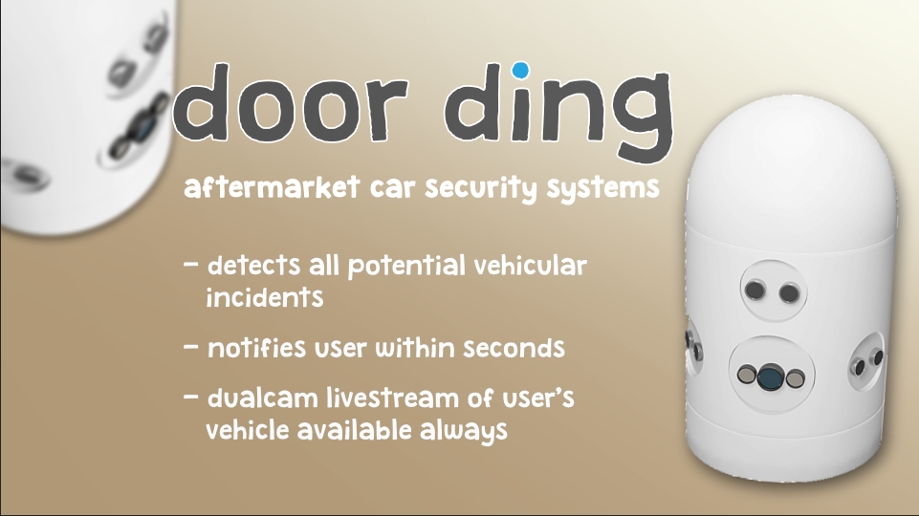Figure 1: A render of a 3D model of the ACSS. Model by Colton Curtis.

An important part of our project is response time: the user should be alerted of a possible incident within a reasonable amount of time. The system also begins to record information and send it to cloud services, allowing evidence to be collected for possible police filing.

Responsibilities
Since the beginning of this semester, I have assumed many different responsibilities. Since I was in charge of machine vision last semester, I took charge of other camera-related functions, namely livestreaming. Livestreaming is an essential part of our embedded system, since it gives the user a direct look at what is happening with his or her car. “Livestreaming” also includes figuring out how to record the video to a file directly, and how to upload that to a cloud storage service. I successfully implemented this by the first demo.
The second major responsibility I had was figuring out how to convert a microphone into an audio sensor. This means that instead of recording audio, I needed to figure out a way to detect the ambient volume of the embedded system’s surroundings. If the volume was too high, it might mean that someone was using an angle grinder on the car’s catalytic converter or something similar. I successfully implemented this by the second demo.
My third major responsibility is detecting whether a Bluetooth Low Energy tag is detectable by the Raspberry Pi. This is used to determine whether or not a component has stolen. This feature was successfully implemented by the third demo.
My last major responsibility was much larger and more important than all the other ones. At the end of Demo 3, I was given the final wooden chassis with the majority of sensors physically installed on it. My task was to get the two Pis communicating with each other, and to have the final product ready in time for both the Expo and the Final Demo. As previously stated, this responsibility was the largest of all, since the whole project was riding on me at the end of the semester.

Overall Progress Report
I believe that we progressed very smoothly throughout our project, minus the final sprint at the end. Throughout the lifespan of the project, we were constantly thinking of ways to add to the system or remove components and features that were unnecessary. For example, we decided to scrap the idea of using machine vision. During the final sprint, we were forced to abandon a lot of ideas that were deemed less important in the interest of time. This included the idea of an on and off button and the WebGL app to display information, both of which were demonstrated in Demo 3. Another big aspect of our project that we had to abandon is the chassis: we had a 3D model ready to print, but the lead times to print at the university library was too long, so we had to abandon the idea. If we would have had more time, we would have implemented all the features we had to abandon, and more.

What We Learned
During this project, my team and I had to get neck-deep in topics that we were all unfamiliar with, meaning we learned a lot these last two semesters. Some topics I learned personally were managing AWS servers since we rented out an EC2 instance for our server. Another thing I learned is how to manage an NGINX server. I learned that early on when I figured out how to implement livestreaming. I also had to figure out how to restore it to a working state after one of my teammates ruined it trying to follow a guide. Naturally, I learned or expanded my knowledge on all the things I worked on personally during the project’s lifespan, including but not limited to livestreaming using RTMP, HLS, and DASH; integrating that livestream on a React website; the Bluetooth stack on Linux; CORS errors and how to fix them; and many other small lessons along the way.

What We Would Have Done Differently
If we had another chance at making this project, I think we would have started with the completed model as soon as possible. A lot of difficulty was encountered because we failed to print the model in time. In fact, a lot of our problems would have been solved if we would have had extra time. We skipped out on a lot of testing as well, so more testing is something we would have done differently. One other thing that we would have done is improved our website a little more. It is rather plain and slow to load due to all the large assets we are loading in.

Feedback for the Professor
I think the professor did a good job proctoring the class. One thing I would have liked to see is a table at the front of the room, so that projects can be displayed at the front of the room instead of having to display it next to your table.

Expected Final Grade
I expect to receive an A for this class. The purpose of this class, according to the CSULB catalog, is to “build, program and verify operation of project started in prior design course.” So far, we have significant progress in building, programming, and verifying the operation of ACSS, our embedded system that was designed last semester. The catalog also says that the team “must submit a written report, give an oral multimedia presentation and provide a working demonstration.” We have definitely submitted our midterm and final reports, and given four oral presentations and working demonstrations (and we even got top three in presentation rankings on the first demo). For following and exceeding these course expectations, my team and I should receive at least a B.
The grade of an A implies going beyond the class requirements and completing all the work assigned. I believe we are going above and beyond this by gathering our knowledge of previous classes, and acquiring new knowledge not taught in our classes, and bringing them together in a product that could compete with other real security systems on the market today. In addition to the aforementioned, our team also won the monetization prize at the Expo (though we didn’t get our prize money). It is for these reasons that I believe my team and I should all receive an A this semester.

